1. **. Aim:** To Design Deterministic Finite Automata using simulator to accept the input string “a” ,”ac”,and ”bac”.

Diagram:

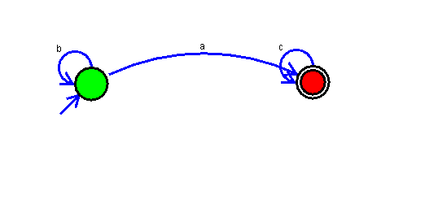

Result:

Successfully executed Deterministic Finite Automata using simulator to accept the input string “a” ,”ac”,and ”bac”.